DOPOLNILNI POUK TJA

REŠITVE:

Postavi besede v pravilen vrstni red in tvori povedi.

My favourite dessert is chocolate.
We have breakfast in the morning.
Nejc eats soup, chips, meat and salad for lunch.
What do you put in your favourite sandwich?
I don’t like eggs.
We cook soup in a pot.
What’s the time?
My birthday is on Saturday.
It’s two o’clock.
There is a king.

OBVEZNO DELO!

10. 4. 2020 (6. šolska ura)

1. Poveži nasprotja in jih dodaj k ustrezni živali.

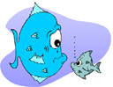

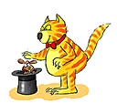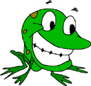
long
new
thin
young
tall, sad
sad
happy
fat
short
old
big

old
big

2. Dokončaj povedi z ustreznimi besedami iz 1. naloge.

I am nine today. It’s my birthday party . I am _____________.

My friend is Alex. He is very _____________ .

Jack is my baby boy. He is very ______________.

My grandmother is Ann. She is 87. She is very ___________.

Jamie can’t swim. He is ______________.

The Nile is a _________ river.

Mouse is a __________ animal.

Look at my ________ umbrella!

Sue likes chocolate. She is __________.
This book has got only twenty pages. It is very __________.

Slovarček:
- pages = strani v knjigi
- The Nile = reka Nil
- look at = poglej, glej, gledaj

